**AEM TASK – 6**

Creating the author component to get the book details.

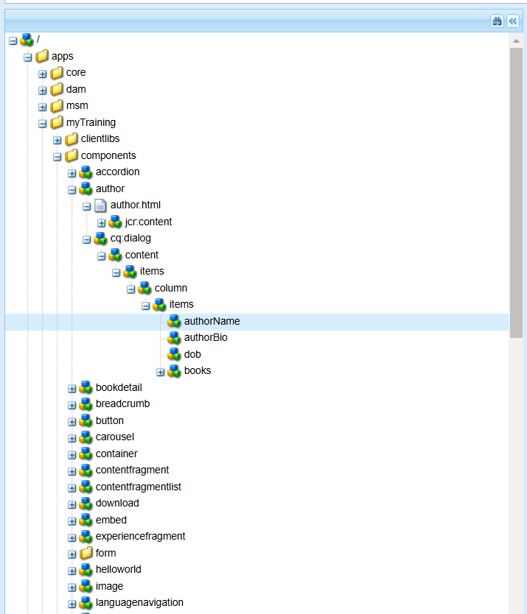

The html file of author component is created to get the details of the book in the author dialog.

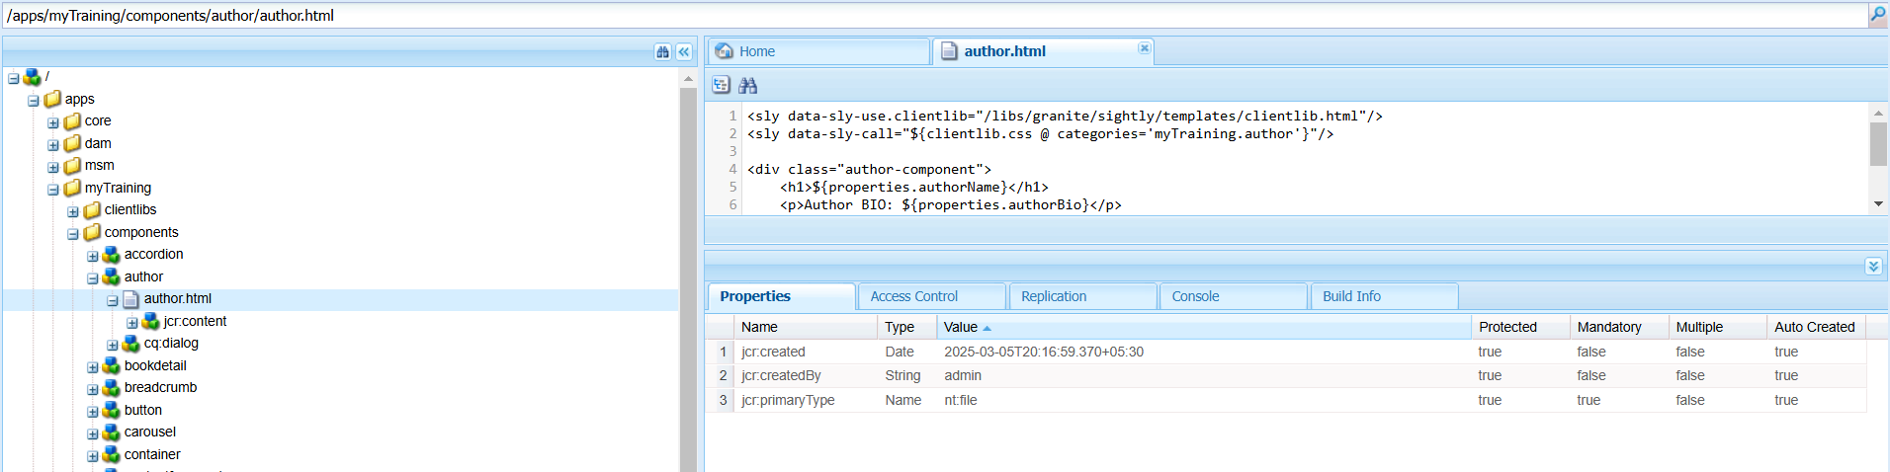

The styling for the author component is given in the clientlibs as css.txt

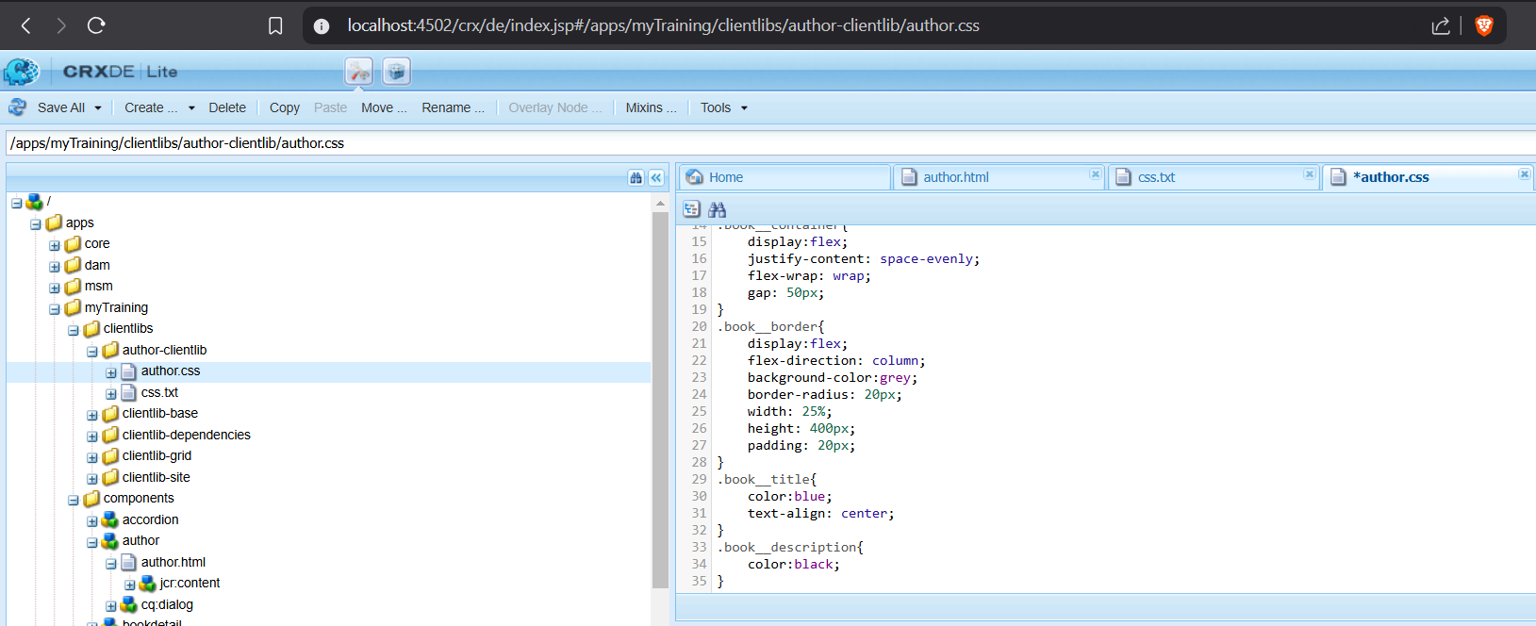

The author component when prompted asks the necessary details to get fetched.

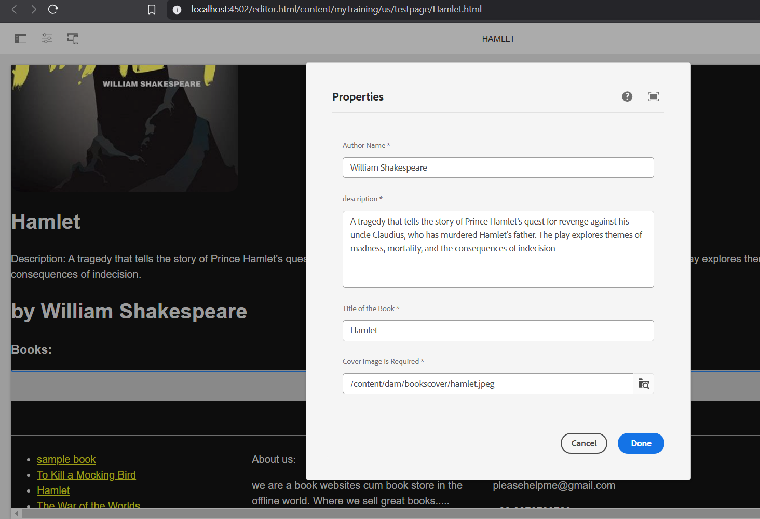

The models are written in the core folder of the project that handles the data request and handling.

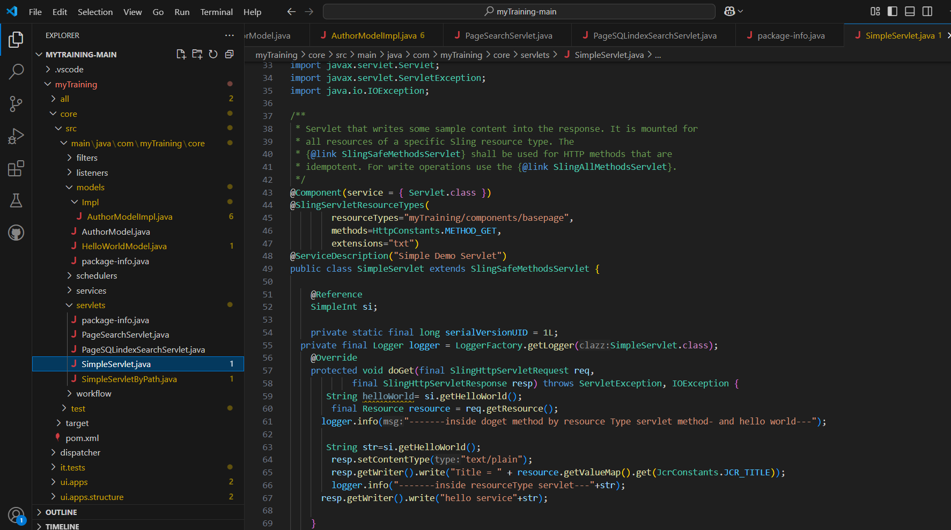

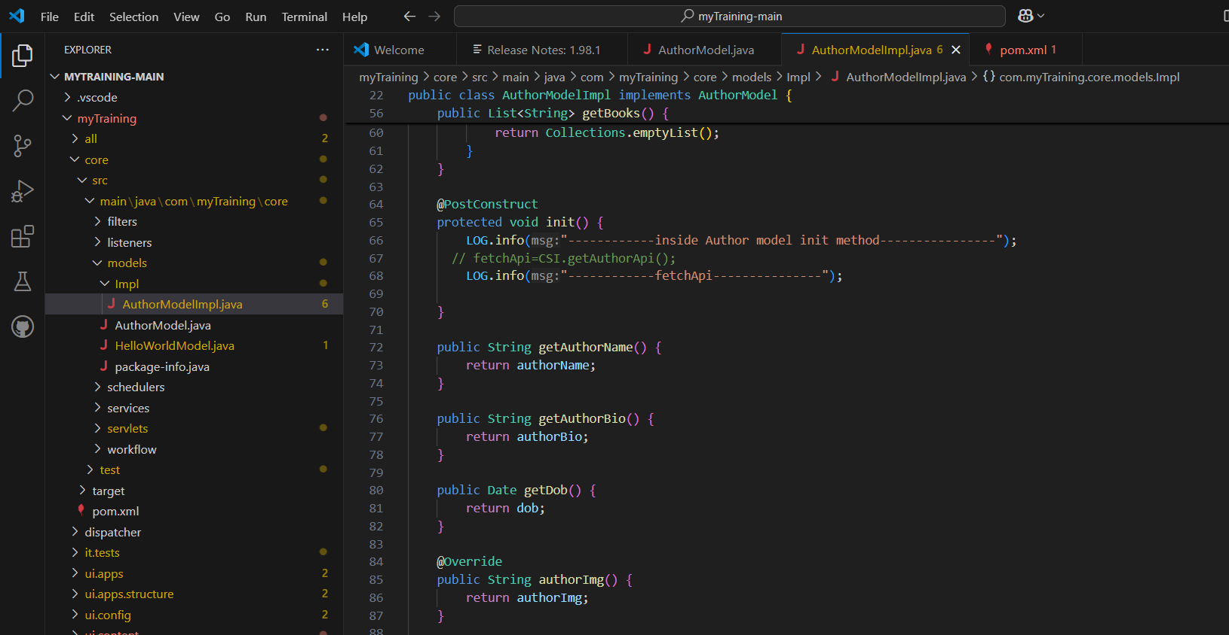

The page consists now of the home and the author details.

